Norwich to Tilbury is a proposal to build a new 400 kilovolt (kV) electricity transmission connection for approximately 180 kilometres from the Norwich Main substation via Bramford substation, a new East Anglia Connection Node (EACN) Substation and a new Tilbury North Substation.

It is a key part of the Great Grid Upgrade, the largest overhaul of the electricity grid in generations. It will enable us to carry more home-grown, cleaner energy from where it is generated to where it is needed, helping to boost energy security, support growing demand for electricity and make Britain more self-sufficient.

Norwich to Tilbury examination closes

  On 10 August 2026, the Planning Inspectorate closed its examination of Norwich to Tilbury. During the examination, which lasted six months, the Examining Authority considered evidence and representations submitted by National Grid, local authorities, statutory bodies, landowners, community groups and members of the public. All documents submitted during the examination remain available on the Planning Inspectorate's website.
  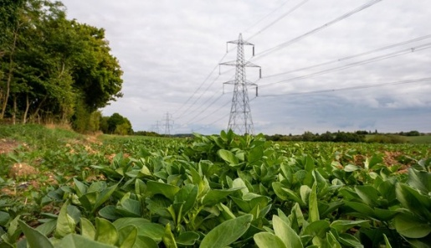

What happens next

The Planning Inspectorate now has three months to prepare a report and recommendation for the Secretary of State for Energy Security and Net Zero, who will decide whether to grant consent for the project. The decision is expected within three months of the recommendation being received.

If we are granted consent, we will start making plans to build the project. We will keep local communities informed and let them know before any work starts in their area.

Surveys

Throughout the development of the project, we have carried out a range of surveys to help inform our proposals and the assessments submitted as part of the planning application.
While examination has now closed, you may still see survey teams working in areas along the proposed route. These surveys help us refine the detailed design of the project and plan for construction.
Surveying the area does not mean construction has started. If you have any questions, please contact the project team using our telephone helpline or email. You can also find the latest information about survey activity on the project website.

Working with landowners

  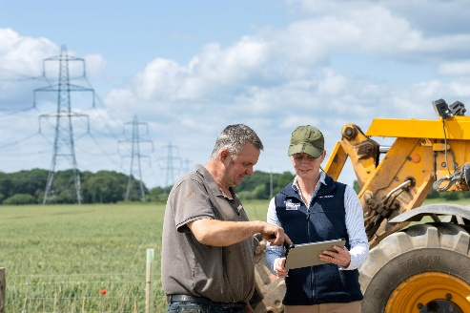
  We aim to work closely with landowners to agree where and when we need to carry out surveys. Sometimes weather conditions can affect our work and can extend or delay survey activity. We try to communicate any changes as soon as possible.
  Some surveying – such as archaeology or traffic monitoring – is also agreed with the relevant local authority or highways authority. Carrying out surveys is required for all major projects such as ours and there may be locations where other developers are also carrying out similar surveys at the same time.

Traffic surveys

We carry out traffic surveys to understand how local roads, footways and cycle routes are used.
The surveys help us build a clear picture of existing travel patterns and how the transport network operates, enabling us to consider how construction activities could affect road users and communities and identify ways to minimise potential impacts.

  Environmental surveys
  Environmental surveys include a range of activities, such as ecological, landscape, ground investigation, water environment, drone and LiDAR surveys. The information gathered helps inform detailed design work and identify opportunities to avoid, reduce or mitigate potential impacts during construction.
  Archaeological surveys
  Archaeological surveys continue to take place along the proposed route to improve our understanding of the area's heritage and identify any archaeological remains that may be present.
  This work can include research, surveys and targeted investigations, helping us better understand the historic environment and ensuring that any important archaeological features are properly considered as the project develops.
  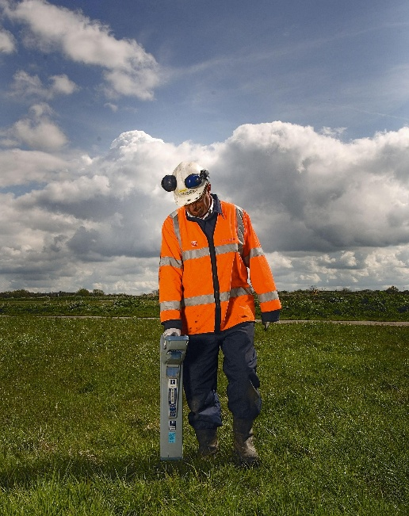

Click here to read more about the types of surveys we are completing for Norwich to Tilbury.



